**NEWSPAPER**

THE TIMES

RATAN TATA

* [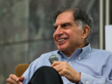](https://economictimes.indiatimes.com/news/company/corporate-trends/ratan-tata-was-one-of-globalizations-giants/articleshow/114301629.cms)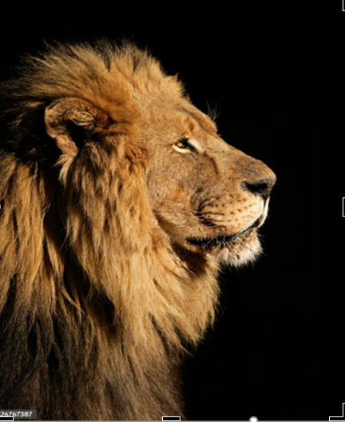 Ratan Tata was born in Bombay (now Mumbai), during the British Raj, into a Parsi Zoroastrian family, on 28 December 1937. Ratan Naval Tata studied architecture and structural engineering in New York's Cornell University, and completed his Bachelor of Science degree in 1962. He joined the Tata Group later that year after a brief stint with Jones and Emmons in Los Angeles
* , **[Ratan Tata launched Nano](https://economictimes.indiatimes.com/interview-with-ratan-tata-making-of-nano/articleshow/2690794.cms" \t "_blank)** at the Auto Expo in 2008. Dubbed as the [**cheapest car**](https://economictimes.indiatimes.com/how-ratan-tata-created-the-nano-like-henry-ford/articleshow/2695485.cms), Nano took [**Tata Motors**](https://economictimes.indiatimes.com/tata-motors-ltd/stocks/companyid-12934.cms) to the world stage making it a case study in many business schools
* **Description**
* Ratan Naval Tata was an Indian industrialist and philanthropist. He served as the chairman of Tata Group and Tata Sons from 1991 to 2012 and he held the position of interim chairman from October 2016 to February 2017. [Wikipedia](https://en.wikipedia.org/wiki/Ratan_Tata)
* **Born:**28 December 1937, [Mumbai](https://www.google.com/search?sca_esv=945b0f90c133864c&biw=1600&bih=773&q=Mumbai&si=ACC90nyvvWro6QmnyY1IfSdgk5wwjB1r8BGd_IWRjXqmKPQqm-k5i_SBEtOsG4nQ6bUodkqr3Raszdb1gRPmM3jhabEkgBJFwPx7j8efRc42ZAE-jab4ESCrCwdoL9y1Gb3xDVuWDO_PydbMydGYXov5q9YmT2R4uxQXszhX_OgeNGcHQu3mNYfvtsfRGp2vlUYg6Ygnp7CM&sa=X&ved=2ahUKEwik3oTJlaSJAxWm7zgGHcD0IPUQmxMoAHoECCQQAg)
* **Died:**9 October 2024 (age 86 years), [Breach Candy Hospital Trust, Mumbai](https://www.google.com/search?sca_esv=945b0f90c133864c&biw=1600&bih=773&q=Breach+Candy+Hospital&si=ACC90ny8E30vD16OoPAAI4cStfcliGy35W8UAhb0TsHNc_ISQYdFJlHInLWlHgeS_LYGXoqPBKBWnP15gQsIjHEzlBLr5cowcbX-1hM-EIUcDTPv_N1X8_z3nSuLP4n0fZEzaJlsoAPLyCYu2mUOVCByf2gsWIMCOxSdMe76QVaBlGV0J0pJSixNPAbS1ESTtMj7p6npW-s8Ijkiym6FO_idN06w3_cq6g%3D%3D&sa=X&ved=2ahUKEwik3oTJlaSJAxWm7zgGHcD0IPUQmxMoAHoECCAQAg)
* **Parents:**[Naval Tata](https://www.google.com/search?sca_esv=945b0f90c133864c&biw=1600&bih=773&q=Naval+Tata&si=ACC90nyByJNAHfkzzi7l4JA4fcQKXOYDCI7plJH6uVksGWg6Xgqc4LI_M3-eESmjQa8rAWxr46HWl862i2f-SE5QP3YWKrnn0n7vc5GVpC_w09gCNSEr646a02DQN8DM9ZwS8KhYgKgaXz091NGLYNSsaZU7_77DUq2zKkNeTrOVHNjZ83OZ2kVyYYnBe25CFX5fTBScu-8yidBQ9S1ceQOpgxa1Auhp2cpwchtJtjM38z0o3cx8jopXow_gTBp8ku5I-Y04gsRmut5rM2CN9Tb8KZrSn0gUEA%3D%3D&sa=X&ved=2ahUKEwik3oTJlaSJAxWm7zgGHcD0IPUQmxMoAHoECCUQAg), [Sooni Tata](https://www.google.com/search?sca_esv=945b0f90c133864c&biw=1600&bih=773&q=Sooni+Tata&si=ACC90ny8E30vD16OoPAAI4cStfcliGy35W8UAhb0TsHNc_ISQeG_e3DDlihdMws1xa6IRt18FNlimnwwHa_0r72jdJ62CmqJjephaXjY4jM29QesCqaVQlkaUkIT-3zipUbtwRzm_QtMjZyqc8Tw26Eo3VlvmUPe33nkd2fncXdLSAgMvBFXAeU2fof093qiGeZK_UYJcYuVXZGRT2oqF23D_1bBO-wuqLuNRolKrIscbdzlgcjqxHLsBOlDPdOshQoCPcXpdMJMLEM8e1tf1QE1DRhh0M5_0Q%3D%3D&sa=X&ved=2ahUKEwik3oTJlaSJAxWm7zgGHcD0IPUQmxMoAXoECCUQAw)
* **Education:**[Harvard Business School](https://www.google.com/search?sca_esv=945b0f90c133864c&biw=1600&bih=773&q=Harvard+Business+School&si=ACC90nyvvWro6QmnyY1IfSdgk5wwjB1r8BGd_IWRjXqmKPQqm18lLGf3Q_ju2_Vk3OclzvlwU8AaGqFtV8d68Oqxuvo8aawy79mQPZ2ZluAWqSnfVfPh2Otg3_ZBQckg7Q6opgtTDGLjpfMnkWEDg0e514QxTKIfNoRAjOm6KvV1dr3MYGmMEoDcTboZf0Fl7n3F_PTGflABH8RAb31-n0QGCg29L4Via_humySLiYLbP7NrGLYPegFpO3M8QOJ7km77-Ue15Y5PLA293BFBbIstPgAXzY5VoQ%3D%3D&sa=X&ved=2ahUKEwik3oTJlaSJAxWm7zgGHcD0IPUQmxMoAHoECCYQAg) (1975) · [See more](https://www.google.com/search?sca_esv=945b0f90c133864c&biw=1600&bih=773&q=ratan+tata+education&stick=H4sIAAAAAAAAAOPgE-LUz9U3MLHMSErXks5OttIvSM0vyEkFUkXF-XlWqSmlyYklmfl5i1hFihJLEvMUSoCkAlwYAL615Z5BAAAA&sa=X&ved=2ahUKEwik3oTJlaSJAxWm7zgGHcD0IPUQ44YBKAF6BAgmEAM)
* **Siblings:**[Noel Tata](https://www.google.com/search?sca_esv=945b0f90c133864c&biw=1600&bih=773&q=Noel+Tata&si=ACC90ny8E30vD16OoPAAI4cStfcliGy35W8UAhb0TsHNc_ISQZ-NYzNWGgsg5OX9lZJAviu1b-Xhja3OJ_JoIdMZhZQhH-qS1NLDbFEm4h9JlhTWo8HUlSKpm6m4qJe-km2s3MD4ALn3ve6wKFiALynQfeFKXhSLpSxPNvWKclDecbYL0pxYuXNSH2oCCXxPM4SOUkmhRPUCvz_TXP3hrnsIXtJXDAT-lBVw_RevDSMYciUKLEAJ8bf3CxEbW6xNssyxvdjLKUXP&sa=X&ved=2ahUKEwik3oTJlaSJAxWm7zgGHcD0IPUQmxMoAHoECCcQAg), [Jimmy Naval Tata](https://www.google.com/search?sca_esv=945b0f90c133864c&biw=1600&bih=773&q=Jimmy+Naval+Tata&si=ACC90nwLLwns5sISZcdzuISy7t-NHozt8Cbt6G3WNQfC9ekAgC-fVmgFAYCGlZ482tqb_0GDT8Qj3AID0McDkW67zsKVML8XzWahDW5WaDJrp5N8PbPC5MyxE-bDnXd91fnVIMKbzmXcE5lMQiscnK-6eEK67neYa8tqVopNDk0J7Az36JV0sv4mYRM8MO6x9FsvbxtdAQq9wWTya84iMmEjaAoiUloLU0aqH-Uew23eEhL4Fw0vUQb4LlbbF-jw38xzlRarFbvunnaV3ULyZWJHnD7LuoOmNA%3D%3D&sa=X&ved=2ahUKEwik3oTJlaSJAxWm7zgGHcD0IPUQmxMoAXoECCcQAw)
* **Height:**1.77 m
* **Awards:**[Order of Australia](https://www.google.com/search?sca_esv=945b0f90c133864c&biw=1600&bih=773&q=Order+of+Australia&si=ACC90nzx_D3_zUKRnpAjmO0UBLNxnt7EyN4YYdru6U3bxLI-L1qnfkPnttjtMM4RWjB_LKDzs57kyB1YEPUCO69yhFfVV0nRbZ-b9_5KW2Jdhs45p5xrIysny6xDxAlkkN9z4JPYGQzExHjQ3cb5yl7CUQnA4PP3Dz-y54P7LfX6CCjc3AgmLf4n8Ac3yzIX0eQbiqzFcfINPOLzVWMTkvR77QZ7GZ92oTDCbWyQHmbK4705iFbWrY069sSoEQ3QVm1DgPwdReHTzC5H8lF_Kizsk1wNrMee6w%3D%3D&sa=X&ved=2ahUKEwik3oTJlaSJAxWm7zgGHcD0IPUQmxMoAHoECCMQAg)

**[Ratan Tata was one of globalization's giants](https://economictimes.indiatimes.com/news/company/corporate-trends/ratan-tata-was-one-of-globalizations-giants/articleshow/114301629.cms" \t "_blank)**

Ratan Tata passed away on October 7. He transformed Tata Group into a global giant, overseeing acquisitions like Jaguar Land Rover and innovations like the Tata Nano. His leadership helped Tata Group grow its worth from $4 billion to $400 billion. His legacy influences India's vision of itself as a global economic player.

* ONE OF THE MOST SUCSESSFUL PERSON IN WORLD

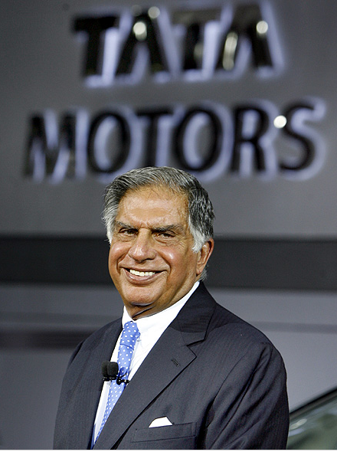

His focus on excellence, innovation, and adaptability have contributed to the success of the Tata Group and his commitment to ethical leadership and corporate social responsibility has earned him respect and admiration.

## Journey of Ratan Tata's triumphs and trials

#### [Ratan Tata with Aria in New Delhi.](http://im.rediff.com/money/2012/dec/20tata10.jpg?_gl=1*4axzs5*_ga*MTA1OTkzNDM0NC4xNzI5NjczMzE4*_ga_3FM4PW27JR*MTcyOTY3MzMxNy4xLjAuMTcyOTY3MzU1NC42MC4wLjA.)

**1937**

Ratan Tata was born on December 28, 1937, in then-Bombay to Naval and Sooni. He began his schooling in Mumbai at Campion School, Bishop Cotton School in Shimla and finished at Cathedral and John Connon School in Mumbai.

**1962**

He completed BS in architecture with structural engineering from Cornell University in the United States in 1962.

**1975**

Tata did Advanced Management Program from Harvard Business School in 1975. He is a member of the Alpha Sigma Phi fraternity.

**1981**

JRD Tata stepped down as Tata Industries chairman, naming Ratan as his successor. He was heavily criticised for lacking experience in running a company of the scale of Tata Industry

**1991**

Tata was appointed group chairman of the Tata group. As group chairman, he has been responsible for converting "the corporate commonwealth" of different Tata-affiliated companies into a cohesive company.

## Journey of Ratan Tata's triumphs and trials

#### [Ratan Tata leaves after addressing a news conference to announce the launch of Jaguar and Land Rover in India, in Mumbai.](http://im.rediff.com/money/2012/dec/20tata19.jpg)

**Image:**Ratan Tata leaves after addressing a news conference to announce the launch of Jaguar and Land Rover in India, in Mumbai.  
**Photographs:**Punit Paranjpe/Reuters

**2000**

Tata Group sells their remaining stake in ACC to the GACL group and exits cement business.

Tata Group and Aditya Birla merge their mobile telephony business, latter rebranded as Idea Cellular.

Tata Tea acquires Tetley Group, United Kingdom, for $450 million, the biggest overseas acquisition by any Indian company till then.